Content Delivery Network

<https://docs.microsoft.com/en-us/azure/cdn/cdn-overview>

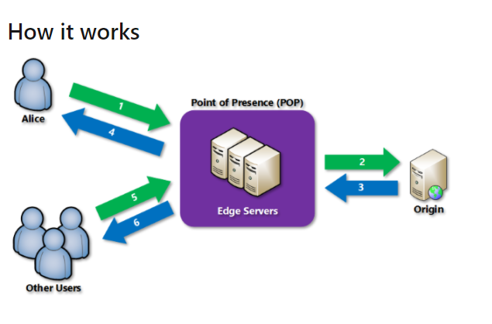

* CDN Endpoint is something your application needs to communicate with to access the the resources required via CDN
* 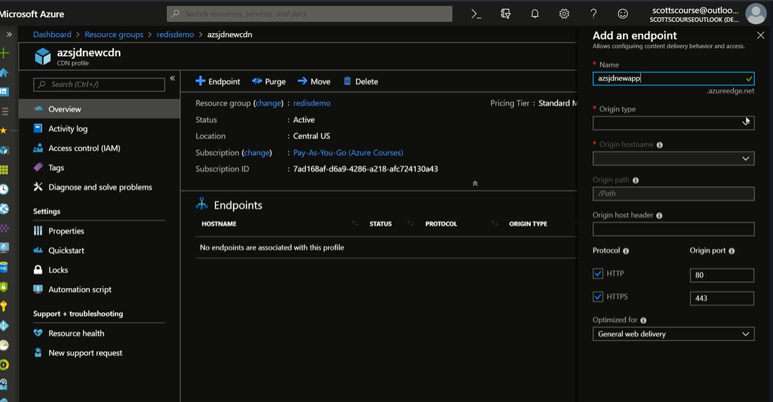
* We can purge the CDN